Mau A: A brief but intensively occupied Late Pleistocene open-air site on the Red River, northern Vietnam

Pham Thanh Son2, Nguyen Thi Mai Huong2, Quinn Habedank1, Isabelle Ami Osuna1, Seungki Kwak3, and Ben Marwick1

March 18, 2024

Abstract

We report on a stone artefact assemblage from Mau A, an open air site by the Red River in northern Vietnam. Artefacts from Mau A, like many sites in mainland Southeast Asia lack visually distinctive and strongly patterned forms, which can make them challenging to analyze and interpret. As a result, many of the dynamics of Pleistocene hunter-gatherers of this region are poorly understood. We explore the use of artefact shape data to investigate relationships between shape and assemblage reduction intensity at Mau A, a brief but intensively occupied site in northern Vietnam. We apply a Principal Components Analysis to two dimensional landmarks of unretouched flakes to investigate shape variation throughout the reduction sequence (measured by dorsal cortex coverage). We find that flake shape varies by reduction stage, primarily through differences in flake length and width. We use three dimensional shape analysis of cores to explore their variability. Our results suggest that flake shape is sensitive to assemblage reduction intensity, and may give useful comparative insights when other attributes show little variation. These results are important for understanding stone artefact assemblages from Southeast Asia which often yield little variation when analysed with long-established approaches.

1 Department of Anthropology, University of Washington  
2 Vien Khao co hoc [Vietnamese Institute of Archaeology]  
3 fosg

Keywords: keyword 1; keyword 2; keyword 3

Highlights: These are the highlights.

While the timing of first stone artefact technologies in mainland Southeast Asia (mSEA) is still uncertain, with claims of over 0.7 Ma (Derevianko et al., 2018) contested on geoarchaeological grounds (Marwick et al., 2021), there is general consensus on the charater of Pleistocene lithic technologies as dominated by flaked stone tools which rarely have strongly patterned forms (Borel et al., 2013; Mijares, 2002). This lack of widely-recognised typo-technological categories for artefacts has slowed progress in understanding the cultural dynamics, relative to regions with more visually distinctive technologies, such as northern Europe and parts of Africa and South America. Much recent work in mSEA has focussed on detailed qualitative documentation of small numbers of cores (e.g. Forestier et al., 2022), with the far more numerous flake component often left unexamined. Meanwhile, novel approaches to quantitative morphometric analyses of lithic assemblages in other regions has demonstrated potential of these methods to address key questions about past human behaviour (Archer et al., 2018; e.g. Okumura and Araujo, 2014; Riede et al., 2024). In island Southeast Asia, applications of this approach have been led by Borel et al. (2017; 2013) demonstrating the potential for quantiative analysis of flake shape on assemblages from Song Terus, Indonesia.

Borel et al. (2017; 2013) employed multivariate analysis of flake outlines in relation to other variables, such as traces of usewear and retouch. They used elliptical Fourier analysis to quantify artefact shape outlines, and summarised shape differences and similarities with Principal Component Analysis. This allowed the outlines of stone tools to be reduced and projected onto a two-dimensional plane, facilitating comparisons between tool morphology and other variables. Borel et al. use outlines rather than traditional linear measurements because these often fail to cover the full variation in shape often seen in stone tools. They found that there was no difference in shape between retouched and unretouched artefacts, and no correlation between a specific overall shape and any specific function indicated by usewear analysis (Borel et al., 2017; Borel et al., 2013).

We build on this pioneering work to explore relationships between shape and lithic reduction in mSEA. In some traditions of lithic analysis, reduction sequence analysis can mean reconstructing a detailed narrative of a single artefact or handful or artefacts, based on the sequence of flake removals indicated by flake scars on the artefact (e.g. Yinghua et al., 2021). There are two important limitations to this approach. First is that it is wasteful because the majority of the assemblage (e.g. the unretouched flakes) are excluded and the information contained in these pieces is not utilized. Ethical fieldwork should prioritize maximizing information gained while minimizing destruction through excavation. Second is that it historically has shown limited potential to provide data to engage with broader anthropological questions about relationships between technology, mobility and risk in hunter-gatherer groups. Tackling these questions has been been highly productive in many parts of the world (Goldstein et al., 2022; Holdaway and Davies, 2020) To address these limitations, our concept of lithic reduction follows Shott (2018) who argues that lithic analysts should “treat curation as a continuous variable, not categorical state, assimilate the time-averaged quality of assemblages as accumulations, reconcile the synchronic behavior it explains with the diachronic accumulations it analyzes, accommodate history as well as adaptation, and transform itself from narrative device to a body of specified, predictive theory”. Heeding this call, we investigate artefact shape as a continuous variable and investigate how it varies as cores are increasingly reduced in an assembalge representing a relatively short period.

The goal of our study is to examine the relationship between shape and lithic reduction in the assemblage at Mau A, northern Vietnam. We ask how flake shape correlates with artefact size and reduction stage. We present a method that uses sets of basic linear measurements of artefacts and converts these into coordinates for shape landmarks. Our approach exhibits a sensitivity to morphological variation not seen with traditional linear measurements, and can be regarded a method for more usefully employing existing linear measurement data in the study of stone tool morphometrics.

## Excavations at Mau A

Mau A is an open air archaeological site located on the banks 5 m above the Red River in Yen Bai Province, Northern Vietnam, at the confluence of a small stream entering the river Figure 1. Excavations were conducted in 2015 by a collaboration including researchers from the University of Washington, the Yen Bai Provincial Museum, the Institute of Archaeology in Hanoi, and the Vietnam National University - Social Sciences and Humanities. We resurveyed the site location in 2022 and found that the excavation area had been built over by houses. An area of 2 x 2 m was excavated in 13 units of ten centimeters deep, through dense silty clay deposits to a depth of about 1.3 m below the surface. Subtle changes in stratigraphy indicated a slightly sloping deposit with four layers, consistent with reports of excavations in this location in the 1980s. The four layers were identified by the type and amount of artefacts present in each. A small amount of plastic and modern ceramics were found in the uppermost 0.1 m of deposit, we identified this is the first layer. Below this was a layer where ceramics and plastics were absent, and a low density of flaked stone artefacts were observed. The most striking feature identified during our excavations was the third layer, which was distinctive as very dense layer of flaked stone artefacts at about 0.6-1.1 m below the surface. No other features were identified during excavation. Below the third layer was sterile deposit to the maximum depth of the excavation at 1.3m. The excavation stopped due to time limitations, bedrock was not encountered.

|  |
| --- |
| Figure 1: Site plan of the Mau A excavation. The lower panel on the right shows the regional context in Souteast Asia. The area of the upper panel is indicated by the red rectangle. The upper panel shows the topography and rivers of northern Vietnam, indicating the location of Yen Bai, the town where the site is located, and Hanoi, the nearest large city. Topographic map of Vietnam created by Sadalmelik with GMT from publicly released GLOBE data, distributed under a CC0 license. |

|  |
| --- |
| Figure 2: Section drawing of the Mau A excavation. The lower panel shows the south and west walls of the excavation. All objects in the section are rocks. The locations of the four radiocarbon samples are shown by their sample IDs. Upper left: excavation in progress by students from the Vietnam National University and the University of Washington. Upper right: photograph of the west wall of the excavation. |

This dense lithic layer contained the majority of stone artefacts recovered from the site. In brief, the *chaîne opératoire* of Mau A lithic technology began with the aquisitions of ovoid river cobbles from the banks of the Red River. This was followed by unifacial shaping on the long sides of flat ovoid cobbles to produce sumatraloids (sumatralith-like pieces). A second sequence, operating in parallel, involved the shaping of thick, blocky ovoid cobbles for the production of choppers or chopping-tools. Finally, we observed a third sequence resulting in the production of longitudinally split half-cobbles. These split cobbles were further shaped into tools with transverse cutting edges. Overall, the flake present scar surfaces and edges that are fresh and unweathered, with no concretions, indicating *in situ* production and limited post-depositional movement. Flakes are mostly made from quartzite, unretouched, complete, small, thin, and lacking dorsal cortex.

## Chronological and Environmental Context

Four radiocarbon ages were obtained from isolated charcoal fragments in the deposit, due to the absence of features such as hearths. The charcoal was sampled to bracket the upper and lower boundaries of the dense lithic layer. The ages indicate a rapid accumulation process for this layer at the terminal Pleistocene. The overlap of all of the highest density ranges for each of the four ages in Figure 3 further shows that these ages are approximately equivalent. Consequently, we treat the lithic assemblage as effectively representing a single event of lithic production and discard and we do not investigate change over time at this site.

The radiocabon ages at Mau A situate human occupation in the Bølling-Allerød interstadial (14,321–12,824 years before present), globally a period of warmer conditions. Isotope analysis of a speleothem collected from Hoa Huong cave, central Vietnam, indicates a lengthy dry period spanning the Last Glacial Maximum (c. 20 ka) followed by an abrupt shift to wetter conditions at onset of the Bølling-Allerød interstadial at ~14 ka and persisting into the Holocene (Patterson et al., 2023).

Analysis of pollen from Mau A show results that are broadly consistent with this global and regional situation of wetter conditions. Twenty-three sediment samples were collected from square B1 and processed to extract pollen and spores (Son, 2020). We found a low concentration of pollen and spores, with arboreal pollen dominant (56%) represented by Poaceae, Typha sp.; Amaranthaceae; Compositae and Cyperaceae. Arboreal pollen (17%) included Pinus sp.; Fagaceae; Magnoliaceae, and fern spores is 27%. Below 75cm we did not found any arboreal pollen, but in contrast, non-arboreal taxa were found throughout, e.g. Poaceae and Compositae. Because of the low pollen concentration, it is difficult to discuss the local environmental context of the site, there is only one signal of wet condition based on the appearance of Typha sp. pollen at 5-30 cm and 50-65 cm below the surface (Fig 4.8-4.9). Overall the pollen data suggest that this location was subject to relatively wet conditions.

Palaeoshoreline reconstructions indicate that current sea levels were established at around 12 ka (Duong et al., 2020). At the time Mau A was occupied, sea levels may have been up to 70m lower than present (Funabiki et al., 2007).

|  |
| --- |
| Figure 3: Radiocabon ages for Mau A, showing the probability density distribution of individual calibrated dates as ridgeplots. The order of the ages on the y-axis follows the depths that the samples were collected from. The red lines below each distribution indicte the highest density age range (94% for all except 57% for A1-2-6). Full details of the radiocarbon ages can be found in the research compendium. |

# Methods

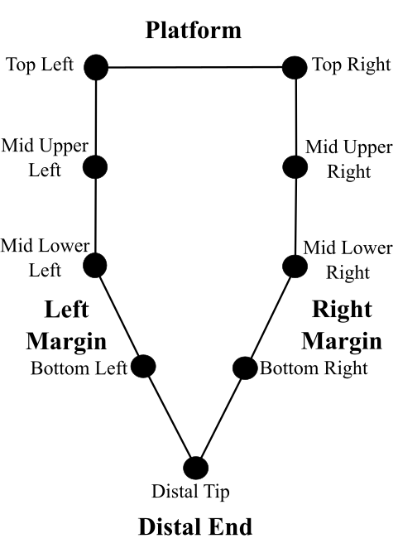

Schematic figure showing the location of our landmarks on a hypothetical flake

Dorsal cortex percentages discretized upon standard cut points were used to create reduction categories. Flakes with no dorsal cortex were categorized as tertiary flakes, those with up to a dorsal cortex percentage of 50% were considered secondary and those with a dorsal cortex value greater than 50% were considered primary (Bradbury & Carr 1995).

Mass clusters were generated using univariate k-means, with the end result being 6 mass clusters, with mass cluster 1 having the least mass on average and 6 having the greatest mass on average. Univariate k-means is a non-hierarchical clustering technique that creates a set number of groups equal to k, with points being assigned to groups in such a manner that the total distances between each point and mean of the group is minimized. The algorithm used for univariate k-means calculates the optimum number of groups. We used the Ckmeans.1d.dp package in R to perform our univariate k-means analysis (Wang & Song, 2011). The Ckmeans.1d.dp has been used for univariate clustering in applications outside of archaeology (Song & Zhong, 2020).

We initially recorded conventional linear dimension measurements, such as max dimension length and width at various points along the max dimension length, from all flakes recovered from the excavation. Then we converted these linear dimensions into landmarks points to represent the shape of each artefact. The specific linear measurements used to create the 2D landmarks were the top horizontal measurement, the max dimension length, width at a quarter of the maximum length, width at half of the maximum length, and width at three quarters of the maximum length.

In analysing the landmarks we followed a conventional shape analysis workflow of Generalized Procrustes Analysis (GPA) followed by Principal Components Analysis (PCA) (Riede & Pedersen, 2018; Hoggard et al., 2019; Radinović & Kajtez, 2021; Okumura & Araujo 2014; Archer et al., 2021; Theska et al. 2020). We used GPA to normalize landmarks for size, orientation, and rotation, leaving only shape data. The normalized landmarks were then analysed by PCA, a form of exploratory data analysis. Principal Component Analysis takes the initial set of data and transforms and reduces them into a smaller set of variables, whist still preserving most of the variation. To explore the output we made PCA biplots of the first two Principal Components to visualize shape variation based upon secondary categorical variables, namely flake reduction categories, excavation units, and mass clusters.

# Results

## Principal Components Analyses exploring flake shape variation

No curves detected; all points appear to be fixed landmarks.

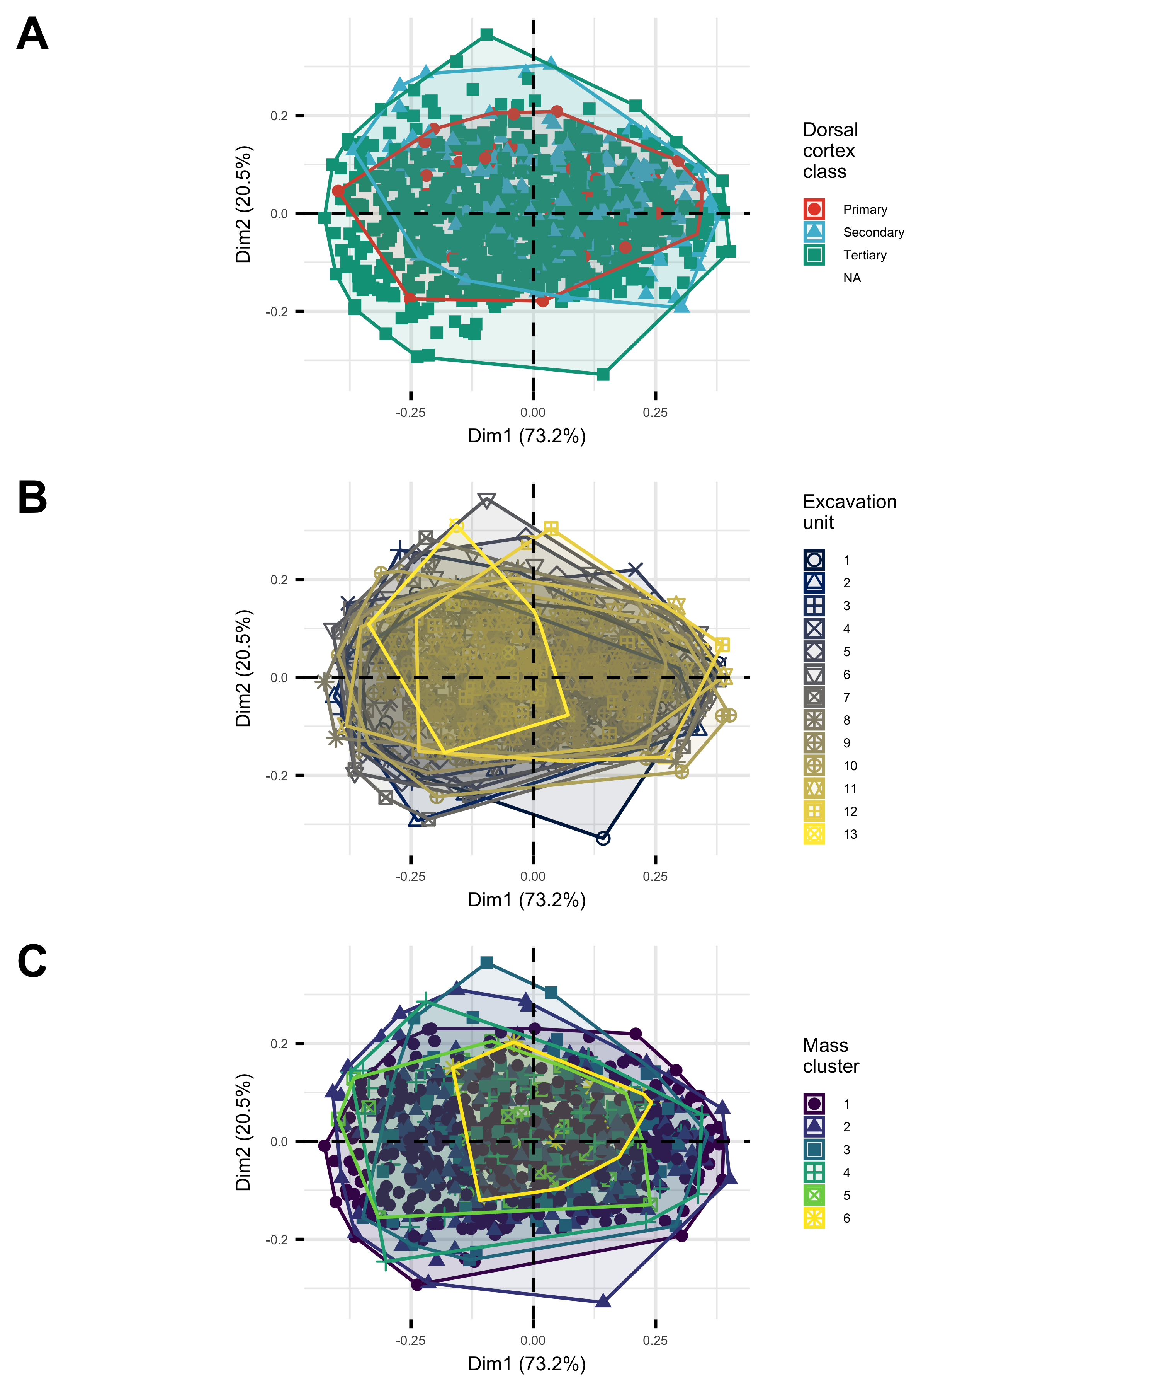

PCA biplots showing (A) variation in flake shape with dorsal cortex class, (B) depth below surface, and (C) mass cluster

Figure @ref(fig:three-pca-biplots)A shows flake shape (as defined within the first two principal components) in relation to dorsal cortex class. The primary class of dorsal cortex, representing initial, unretouched flakes in the reduction sequence, has the smallest range of shape variation. Secondary flakes, which have been retouched and thus have less dorsal cortex than the primary flakes, show a slightly larger range of shape variation. Lastly, the tertiary flakes at the end of the reduction sequence show the greatest amount of shape variation.

Shape variation is not equal along both principal components. For flakes in all three dorsal cortex classes, the largest differences between each inter-nested is along the first principal component. Slight differences are seen along the second principal component, with an increasing amount of variation as one goes from primary to secondary to tertiary flakes, but these changes are minor when compared to the larger changes seen in the first principal component.

Figure @ref(fig:three-pca-biplots)B shows the flake shapes projected on the first two principal components, and colored according to the excavation unit that they were recovered from. Excavation unit one is near the surface, and unit 13 is near the base. The general picture here is that shape variation changes little through the deposit. Units with fewer flakes, such as 13, show lower shape variation.

In Figure @ref(fig:three-pca-biplots)C we see that greater shape variation is found in the lightest mass classes. The two lightest mass clusters, one and two, are in purple and blue respectively. These first two mass classes span the largest area on the biplot, signifying a larger degree of variation overall.

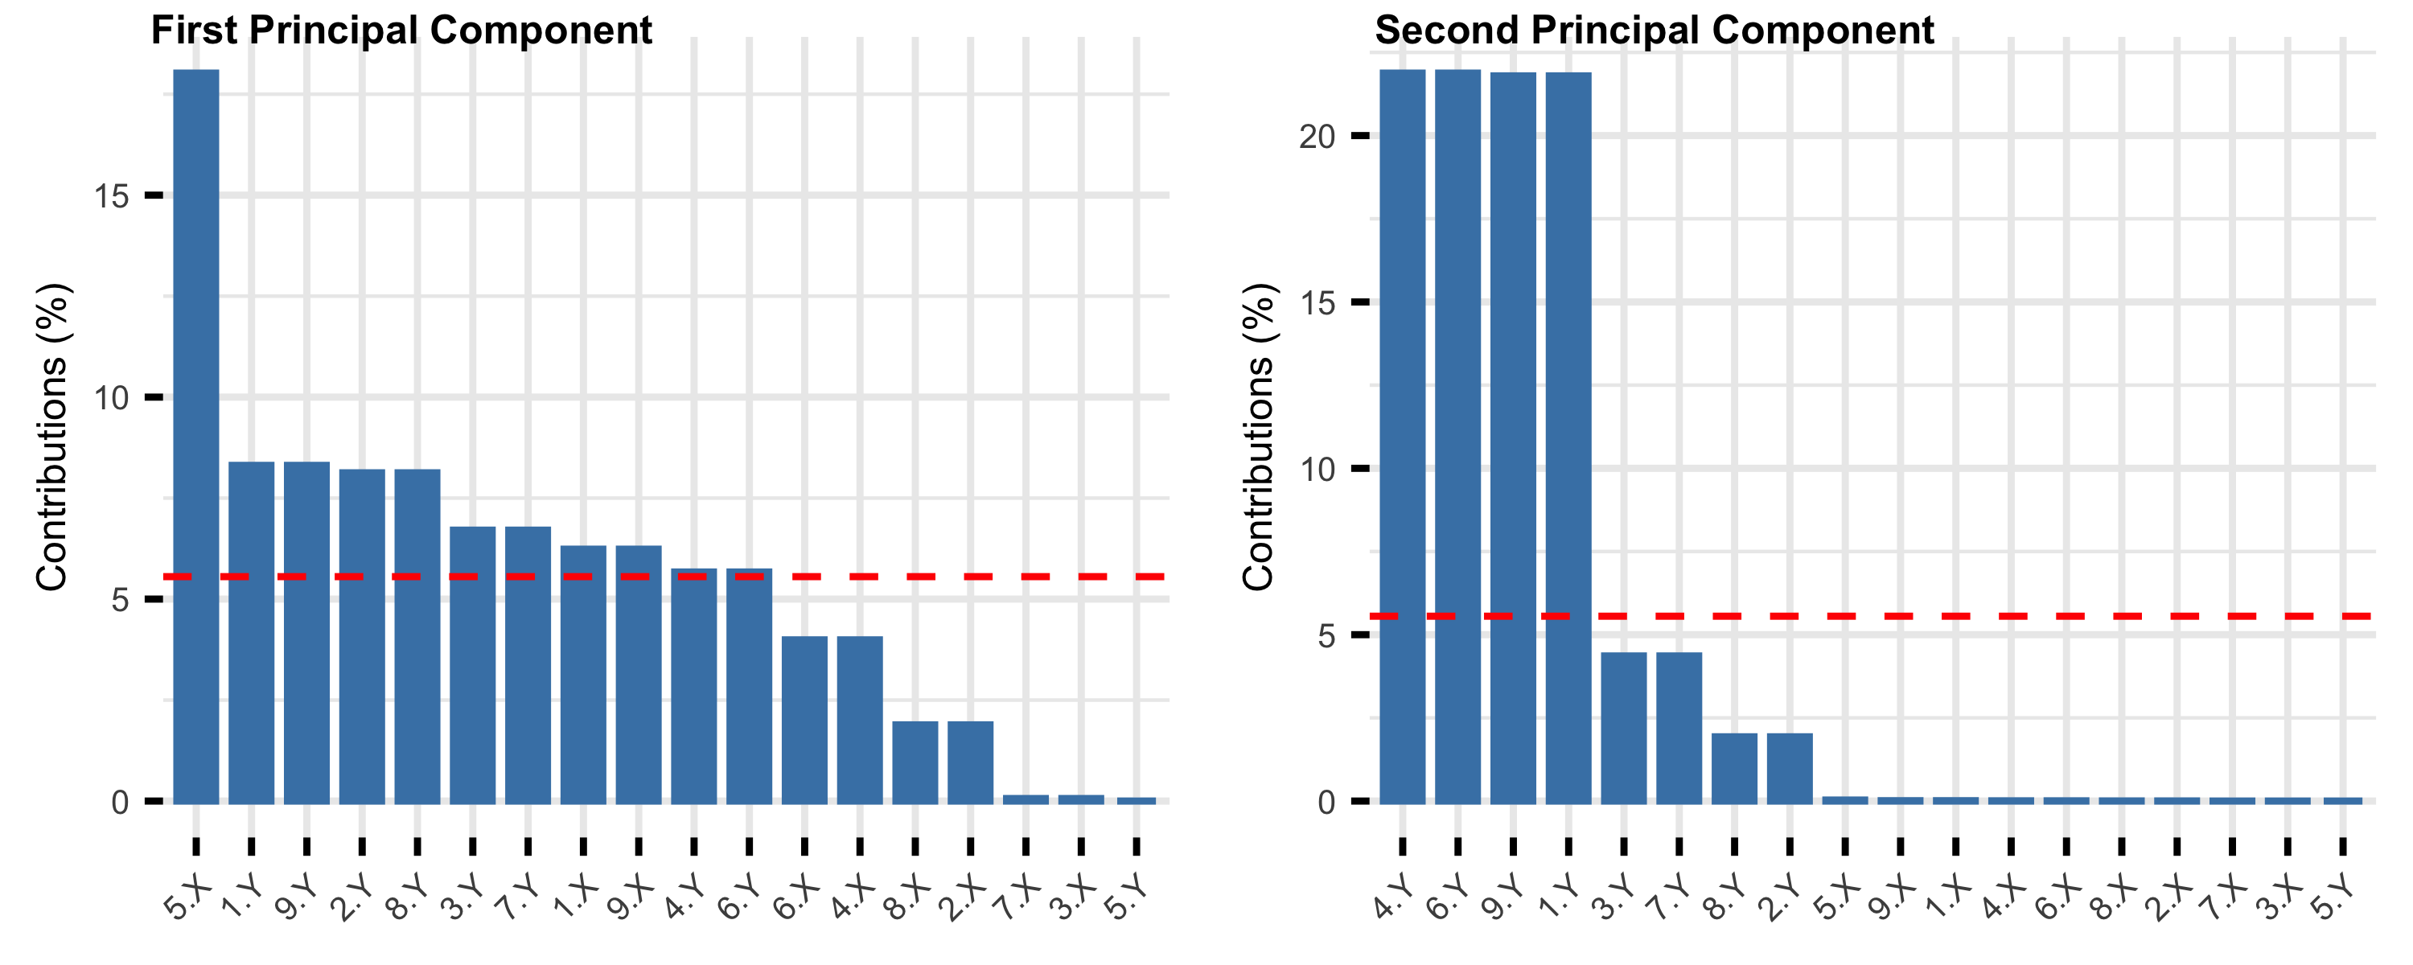

Plots showing the contribution of landmarks to the first two Principal Components (A: PC1, B: PC2) that summarise the overall shape variation among flakes. The dashed red horizontal line corresponds to the expected value if the contribution from each landmark was uniform.

Figure @ref(fig:contribution-plots) shows the relative contribution of each of the original 18 variables put through our PCA. The first principal component is primarily composed of the x-value for the distal tip landmark, with smaller contributions from the y-values from the two upper-most and mid-upper points. The second principal component is composed largely of the y-values for bottom-most and upper-most points.

## Principal Components Analyses exploring core shape variation

# Discussion

Flake shape variation generally shows limited correspondence with other factors. Figure @ref(fig:excavation-unit-biplot)B shows very little variation over time, with lots of overlap between groups in the biplot. Units with fewer flakes, such as 13, show lower shape variation. This generally confirms our conclusion from the radiocarbon ages that the deposit accumulated relatively quickly, and the assemblage represents knapping events occurring at a similar time with little, if any perceptible change over time. By contrast, a more definitive difference between groups in seen in Figure @ref(fig:excavation-unit-biplot)C, where there is a high degree of shape variation in the lightest flakes. This reflects the production of different types and shapes of cores as the flakes become smaller and thus lighter. This is further supported by Figure @ref(fig:excavation-unit-biplot)A where tertiary flakes with little dorsal cortex show the highest shape variation. This supports our interpretation of the previous result, with flakes from later in the reduction process showing greater shape variation as different types of cores were produced at the site.

The lack of distinct morphological groupings and the increased variability of shape in the smaller, tertiary flakes is consistent with previous studies. Other studies which investigated the morphology of flake outlines from South East Asia concluded that there is no significant relationship between flake outline and flake use (Borel et al., 2013; Borel et al., 2017). While our analysis not rely upon outlines, both outlines and landmarks are ultimately methods for measuring the morphology of flaked stone tools, and as such, the same models which explain outline variability can be cautiously applied to our analysis. The large amount of variability in flake shape, especially in the tertiary flakes, suggests that the knappers were not looking to create a specific shape of flake, with the amount of variability increasing as flakes are struck off of increasingly differed cores. This behavior is consistent with processes of expedient knapping, where a large number of flakes are created in a relatively free-form manner and useful flakes are picked up and used after knapping is finished (Holdaway & Douglass, 2012; McCall, 2012). Processes of expedient knapping suggest that stone tools were of secondary importance in the material culture of the knappers (Sillitoe & Hardy, 2003). Elsewhere it has been suggested stone tools were primarily used to create bamboo tools in South East Asia (Mijares, 2001). A reliance upon bamboo tools, with stone flakes merely being an intermediary to produce bamboo tools, would explain the great variability in the lithic assemblages at Mau A.

In Figure @ref(fig:contribution-plots), we can see that the distal tip, the top right, and the top left landmarks are the top three contributors to each principal component. We interpret this as indicating that the first principal component is primarily influenced by artefact length and platform width. The second principal component primarily consists of the bottom left, bottom right, top left, and top right landmarks; we interpret this as the second principal component representing surface area of the artefact.

The lack of distinct morphological groupings and the increased variability of shape in the smaller, tertiary flakes is consistent with previous studies. Other studies which investigated the morphology of flake outlines from South East Asia concluded that there is no significant relationship between flake outline and flake use (Borel et al., 2013; Borel et al., 2017). While our analysis does not rely upon outlines, both outlines and landmarks are methods for measuring the morphology of flaked stone tools, and as such, the same models which explain outline variability can be cautiously applied to our analysis. The high variability in flake shape, especially in the tertiary flakes, suggests that knappers were not looking to systematically create a small set of specific shapes of flake, with the amount of variability increasing as flakes are struck off of increasingly differed cores. It is also possible that the knappers were aiming to create a wide range of shapes, or that a great number of flakes were created of certain shapes with considerable variation between flakes. This behavior is consistent with processes of expedient knapping, where a large number of flakes are created in a relatively free-form manner and useful flakes are picked up and used after knapping is finished (Holdaway & Douglass, 2012; McCall, 2012). Processes of expedient knapping suggest that stone tools were of secondary importance in the material culture of the knappers (Sillitoe & Hardy, 2003), relative to organic technologies. Mijares (2001) suggested stone tools were primarily used to create bamboo tools in South East Asia. A reliance upon bamboo tools, with stone flakes being an intermediary to produce bamboo tools, may explain the great variability in the lithic assemblages at Mau A.

# Conclusion

This work demonstrates the applicability of our new method in identifying the shape changes that accompany lithic reduction within a paleolithic MSEA assemblage. Our method for converting linear measurements into shape landmarks demonstrates a sensitivity to morphological diversity that opens the door for further applications. Our finding support the conclusions of Borel et al. (2017) that linear measurements rarely capture the full breadth of variation seen in stone tools. Our approach of taking linear measurements and converting them into landmarks gives more options for examining the sensitivity of shape variation to a variety of factors compared to the use of linear measurements alone. While the generated landmarks that we use here might not be as sensitive as full artefact outlines, linear measurements of stone tools are simple to collect with basic equipment. As a result, there are many opportunities to apply our method to existing linear measurement data on legacy assemblage.

# Acknowledgements

# References

Archer, W., Djakovic, I., Brenet, M., Bourguignon, L., Presnyakova, D., Schlager, S., Soressi, M., & McPherron, S. P. (2021). Quantifying differences in hominin flaking technologies with 3D shape analysis. Journal of Human Evolution, 150, 102912. https://doi.org/10.1016/j.jhevol.2020.102912

Borel, Antony, Richard Cornette, and Michel Baylac. 2017. “Stone Tool Forms and Functions: A Morphometric Analysis of Modern Humans’ Stone Tools From Song Terus Cave (Java, Indonesia).” Archaeometry 59 (3): 455–71. https://doi.org/10.1111/arcm.12264.

Borel, Antony, Claire Gaillard, Marie-Hélène Moncel, Robert Sala, Emmanuelle Pouydebat, Truman Simanjuntak, and François Sémah. 2013. “How to Interpret Informal Flakes Assemblages? Integrating Morphological Description, Usewear and Morphometric Analysis Gave Better Understanding of the Behaviors of Anatomically Modern Human from Song Terus (Indonesia).” Journal of Anthropological Archaeology 32 (4): 630–46. https://doi.org/10.1016/j.jaa.2013.03.002.

Bradbury, Andrew P., and Philip J. Carr. “Flake Typologies and Alternative Approaches: An Experimental Assessment.” Lithic Technology 20, no. 2 (1995): 100-15. Accessed June 11, 2021. http://www.jstor.org/stable/23273168.

Demeter, F., Shackelford, L., Westaway, K., Barnes, L., Duringer, P., Ponche, J.-L., Dumoncel, J., Sénégas, F., Sayavongkhamdy, T., Zhao, J.-X., Sichanthongtip, P., Patole-Edoumba, E., Dunn, T., Zachwieja, A., Coppens, Y., Willerslev, E., & Bacon, A.-M. (2017). Early Modern Humans from Tam Pà Ling, Laos: Fossil Review and Perspectives. Current Anthropology, 58(S17), S527–S538. https://doi.org/10.1086/694192

Forestier, H., Zhou, Y., Sophady, H., Li, Y., Codeluppi, D., Auetrakulvit, P., & Zeitoun, V. (2022). The first lithic industry of mainland Southeast Asia: Evidence of the earliest hominin in a tropical context. L’Anthropologie, 126(1), 102996. https://doi.org/10.1016/j.anthro.2022.102996

Hoggard, C. S., McNabb, J., & Cole, J. N. (2019). The Application of Elliptic Fourier Analysis in Understanding Biface Shape and Symmetry Through the British Acheulean. Journal of Paleolithic Archaeology, 2(2), 115–133. https://doi.org/10.1007/s41982-019-00024-6

Holdaway, S., & Douglass, M. (2012). A Twenty-First Century Archaeology of Stone Artifacts. Journal of Archaeological Method and Theory, 19(1), 101–131. https://doi.org/10.1007/s10816-011-9103-6

McAdams, C., Morley, M. W., Fu, X., Kandyba, A. V., Derevianko, A. P., Nguyen, D. T., Doi, N. G., & Roberts, R. G. (2020). The Pleistocene geoarchaeology and geochronology of Con Moong Cave, North Vietnam: Site formation processes and hominin activity in the humid tropics. Geoarchaeology, 35(1), 72–97. https://doi.org/10.1002/gea.21758

McAdams, C., Morley, M. W., Fu, X., Kandyba, A. V., Derevianko, A. P., Nguyen, D. T., Doi, N. G., & Roberts, R. G. (2022). Late Pleistocene shell midden microstratigraphy indicates a complex history of human–environment interactions in the uplands of northern Vietnam. Philosophical Transactions of the Royal Society B: Biological Sciences, 377(1849), 20200493. https://doi.org/10.1098/rstb.2020.0493

McCall, G. S. (2012). Ethnoarchaeology and the Organization of Lithic Technology. Journal of Archaeological Research, 20(2), 157–203. https://doi.org/10.1007/s10814-011-9056-z

Mijares, A. S. B. (2001). An Expedient Lithic Technology in Northern Luzon (Philippines). Lithic Technology, 26(2), 138–152. https://doi.org/10.1080/01977261.2001.11720983

Mijares, A. 2008. “The late pleistocene to early holocene foragers of northern Luzon.” Bulletin of the Indo-Pacific Prehistory Association 28: 99-107.

Okumura, M., & Araujo, A. G. M. (2014). Long-term cultural stability in hunter–gatherers: A case study using traditional and geometric morphometric analysis of lithic stemmed bifacial points from Southern Brazil. Journal of Archaeological Science, 45, 59–71. https://doi.org/10.1016/j.jas.2014.02.009

Radinović, M., & Kajtez, I. (2021). Outlining the knapping techniques: Assessment of the shape and regularity of prismatic blades using elliptic Fourier analysis. Journal of Archaeological Science: Reports, 38, 103079. https://doi.org/10.1016/j.jasrep.2021.103079

Riede, F., & Pedersen, J. B. (2018). Late Glacial Human Dispersals in Northern Europe and Disequilibrium Dynamics. Human Ecology, 46(5), 621–632. https://doi.org/10.1007/s10745-017-9964-8

Shackelford, L., Demeter, F., Westaway, K., Duringer, P., Ponche, J.-L., Sayavongkhamdy, T., Zhao, J.-X., Barnes, L., Boyon, M., Sichanthongtip, P., Sénégas, F., Patole-Edoumba, E., Coppens, Y., Dumoncel, J., & Bacon, A.-M. (2018). Additional evidence for early modern human morphological diversity in Southeast Asia at Tam Pa Ling, Laos. Quaternary International, 466, 93–106. https://doi.org/10.1016/j.quaint.2016.12.002

Sillitoe, P., & Hardy, K. (2003). Living Lithics: Ethnoarchaeology in Highland Papua New Guinea. Antiquity, 77(297), 555–566. https://doi.org/10.1017/S0003598X00092619

Song, M., & Zhong, H. (2020). Efficient weighted univariate clustering maps outstanding dysregulated genomic zones in human cancers. Bioinformatics, 36(20), 5027–5036. https://doi.org/10.1093/bioinformatics/btaa613

Theska, T., Sieriebriennikov, B., Wighard, S. S., Werner, M. S., & Sommer, R. J. (2020). Geometric morphometrics of microscopic animals as exemplified by model nematodes. Nature Protocols, 15(8), 2611–2644. https://doi.org/10.1038/s41596-020-0347-z

Wang, H., & Song, M. (2011). Ckmeans.1d.dp: Optimal k-means Clustering in One Dimension by Dynamic Programming. The R Journal, 3(2), 29–33.

Archer, W., Pop, C.M., Rezek, Z., Schlager, S., Lin, S.C., Weiss, M., Dogandžić, T., Desta, D., McPherron, S.P., 2018. A geometric morphometric relationship predicts stone flake shape and size variability. Archaeological and Anthropological Sciences 10, 1991–2003. <https://doi.org/10.1007/s12520-017-0517-2>

Borel, A., Cornette, R., Baylac, M., 2017. Stone Tool Forms and Functions: A Morphometric Analysis of Modern Humans’ Stone Tools From Song Terus Cave (Java, Indonesia). Archaeometry 59, 455–471. <https://doi.org/10.1111/arcm.12264>

Borel, A., Gaillard, C., Moncel, M.-H., Sala, R., Pouydebat, E., Simanjuntak, T., Sémah, F., 2013. How to interpret informal flakes assemblages? Integrating morphological description, usewear and morphometric analysis gave better understanding of the behaviors of anatomically modern human from song terus (indonesia). Journal Of Anthropological Archaeology 32, 630–646.

Derevianko, A.P., Kandyba, A., Su, N.K., Gladyshev, S.A., Doi, N.G., Lebedev, V.A., Chekha, A.M., Rybalko, A.G., Kharevich, V.M., Tsybankov, A.A., 2018. The discovery of a bifacial industry in vietnam. ARCHAEOLOGY ETHNOLOGY AND ANTHROPOLOGY OF EURASIA 46, 321.

Duong, N.T., Lieu, N.T.H., Cuc, N.T.T., Saito, Y., Huong, N.T.M., Phuong, N.T.M., Thuy, A.T., 2020. Holocene paleoshoreline changes of the Red River Delta, Vietnam. Review of Palaeobotany and Palynology 278, 104235. <https://doi.org/10.1016/j.revpalbo.2020.104235>

Forestier, H., Zhou, Y., Viallet, C., Auetrakulvit, P., Li, Y., Sophady, H., 2022. Reduction Sequences During the Hoabinhian Technocomplex in Cambodia and Thailand: A New Knapping Strategy in Southeast Asia from the Terminal Upper Pleistocene to mid Holocene. Lithic Technology 47, 147–170. <https://doi.org/10.1080/01977261.2021.1981654>

Funabiki, A., Haruyama, S., Quy, N.V., Hai, P.V., Thai, D.H., 2007. Holocene delta plain development in the song hong (red river) delta, vietnam. Journal of Asian Earth Sciences 30, 518–529. <https://doi.org/10.1016/j.jseaes.2006.11.013>

Goldstein, S.T., Shipton, C., Miller, J.M., Ndiema, E., Boivin, N., Petraglia, M., 2022. Hunter-gatherer technological organization and responses to holocene climate change in coastal, lakeshore, and grassland ecologies of eastern africa. Quaternary Science Reviews 280, 107390. <https://doi.org/10.1016/j.quascirev.2022.107390>

Holdaway, S.J., Davies, B., 2020. Surface Stone Artifact Scatters, Settlement Patterns, and New Methods for Stone Artifact Analysis. Journal of Paleolithic Archaeology 3, 612–632. <https://doi.org/10.1007/s41982-019-00030-8>

Marwick, B., Son, P.T., Brewer, R., Wang, L.-Y., 2021. Tektite geoarchaeology in mainland southeast asia. SocArXiv, 93fpa, ver. 6 peer-reviewed and recommended by PCI Archaeology. <https://doi.org/10.31235/osf.io/93fpa>

Mijares, A.S.B., 2002. The minori cave expedient lithic technology. University of the Philippines Press.

Okumura, M., Araujo, A.G.M., 2014. Long-term cultural stability in huntergatherers: A case study using traditional and geometric morphometric analysis of lithic stemmed bifacial points from southern brazil. Journal of Archaeological Science 45, 5971. <https://doi.org/10.1016/j.jas.2014.02.009>

Patterson, Elizabeth W., Johnson, Kathleen R., Griffiths, Michael L., Kinsley, Christopher W., McGee, D., Du, X., Pico, T., Wolf, A., Ersek, V., Mortlock, Richard A., Yamoah, Kweku A., Bùi, Thành N., Trần, Mùi X., ỗ-Trọng, Q., Võ, Trí V., inh, Trí H., 2023. Glacial changes in sea level modulated millennial-scale variability of southeast asian autumn monsoon rainfall. Proceedings of the National Academy of Sciences 120, e2219489120. <https://doi.org/10.1073/pnas.2219489120>

Riede, F., Matzig, D.N., Biard, M., Crombé, P., Pablo, J.F.-L. de, Fontana, F., Groß, D., Hess, T., Langlais, M., Mevel, L., Mills, W., Moník, M., Naudinot, N., Posch, C., Rimkus, T., Stefański, D., Vandendriessche, H., Hussain, S.T., 2024. A quantitative analysis of Final Palaeolithic/earliest Mesolithic cultural taxonomy and evolution in Europe. PLOS ONE 19, e0299512. <https://doi.org/10.1371/journal.pone.0299512>

Shott, M.J., 2018. The Costs and Benefits of Technological Organization: Hunter-Gatherer Lithic Industries and Beyond, in: Robinson, E., Sellet, F. (Eds.),. Springer International Publishing, Cham, pp. 321–333. <https://doi.org/10.1007/978-3-319-64407-3_15>

Son, P.T., 2020. Lithic technology during the late pleistocene and holocene in northern vietnam: A model from yen bai province (PhD thesis).

Yinghua, L., Dung, L.T.M., So’n, ặng H., Fajun, L., Forestier, H., Yuduan, Z., Peng, C., Liwei, W., Chengpo, H., Tingting, L., 2021. [A new technological analysis of hoabinhian stone artifacts from vietnam and its implications for cultural homogeneity and variability between mainland southeast asia and south china](https://muse.jhu.edu/pub/5/article/793771). Asian Perspectives 60, 71–96.

### Colophon

This report was generated on 2024-03-18 22:43:04.303802 using the following computational environment and dependencies:

─ Session info ───────────────────────────────────────────────────────────────  
 setting value  
 version R version 4.3.3 (2024-02-29)  
 os macOS Sonoma 14.1.2  
 system x86_64, darwin20  
 ui X11  
 language (EN)  
 collate en_US.UTF-8  
 ctype en_US.UTF-8  
 tz Asia/Ho_Chi_Minh  
 date 2024-03-18  
 pandoc 3.1.1 @ /Applications/RStudio.app/Contents/Resources/app/quarto/bin/tools/ (via rmarkdown)  
  
─ Packages ───────────────────────────────────────────────────────────────────  
 package * version date (UTC) lib source  
 abind 1.4-5 2016-07-21 [1] CRAN (R 4.3.0)  
 ape 5.7-1 2023-03-13 [1] CRAN (R 4.3.0)  
 backports 1.4.1 2021-12-13 [1] CRAN (R 4.3.0)  
 base64enc 0.1-3 2015-07-28 [1] CRAN (R 4.3.0)  
 Bchron 4.7.6 2021-06-10 [1] CRAN (R 4.3.0)  
 bezier 1.1.2 2018-12-14 [1] CRAN (R 4.3.0)  
 bit 4.0.5 2022-11-15 [1] CRAN (R 4.3.0)  
 bit64 4.0.5 2020-08-30 [1] CRAN (R 4.3.0)  
 broom 1.0.5 2023-06-09 [1] CRAN (R 4.3.0)  
 c14bazAAR * 4.1.0 2024-02-15 [1] https://ropensci.r-universe.dev (R 4.3.2)  
 cachem 1.0.8 2023-05-01 [1] CRAN (R 4.3.0)  
 car 3.1-2 2023-03-30 [1] CRAN (R 4.3.0)  
 carData 3.0-5 2022-01-06 [1] CRAN (R 4.3.0)  
 cellranger 1.1.0 2016-07-27 [1] CRAN (R 4.3.0)  
 checkmate 2.3.1 2023-12-04 [1] CRAN (R 4.3.0)  
 Ckmeans.1d.dp * 4.3.5 2023-08-19 [1] CRAN (R 4.3.0)  
 cli 3.6.2 2023-12-11 [1] CRAN (R 4.3.0)  
 cluster * 2.1.6 2023-12-01 [1] CRAN (R 4.3.3)  
 codetools 0.2-19 2023-02-01 [1] CRAN (R 4.3.3)  
 colorRamps 2.3.1 2022-05-02 [1] CRAN (R 4.3.0)  
 colorspace 2.1-0 2023-01-23 [1] CRAN (R 4.3.0)  
 cowplot * 1.1.3 2024-01-22 [1] CRAN (R 4.3.2)  
 crayon 1.5.2 2022-09-29 [1] CRAN (R 4.3.0)  
 devtools 2.4.5 2022-10-11 [1] CRAN (R 4.3.0)  
 digest 0.6.35 2024-03-11 [1] CRAN (R 4.3.3)  
 doParallel 1.0.17 2022-02-07 [1] CRAN (R 4.3.0)  
 dplyr * 1.1.4 2023-11-17 [1] CRAN (R 4.3.0)  
 ellipsis 0.3.2 2021-04-29 [1] CRAN (R 4.3.0)  
 evaluate 0.23 2023-11-01 [1] CRAN (R 4.3.0)  
 extrafont 0.19 2023-01-18 [1] CRAN (R 4.3.0)  
 extrafontdb 1.0 2012-06-11 [1] CRAN (R 4.3.0)  
 factoextra * 1.0.7 2020-04-01 [1] CRAN (R 4.3.0)  
 fansi 1.0.6 2023-12-08 [1] CRAN (R 4.3.0)  
 farver 2.1.1 2022-07-06 [1] CRAN (R 4.3.0)  
 fastmap 1.1.1 2023-02-24 [1] CRAN (R 4.3.0)  
 forcats * 1.0.0 2023-01-29 [1] CRAN (R 4.3.0)  
 foreach 1.5.2 2022-02-02 [1] CRAN (R 4.3.0)  
 fs 1.6.3 2023-07-20 [1] CRAN (R 4.3.0)  
 generics 0.1.3 2022-07-05 [1] CRAN (R 4.3.0)  
 geomorph * 4.0.6 2023-08-31 [1] CRAN (R 4.3.0)  
 ggforce 0.4.2 2024-02-19 [1] CRAN (R 4.3.2)  
 ggplot2 * 3.5.0 2024-02-23 [1] CRAN (R 4.3.2)  
 ggpubr 0.6.0 2023-02-10 [1] CRAN (R 4.3.0)  
 ggrepel 0.9.5 2024-01-10 [1] CRAN (R 4.3.0)  
 ggridges * 0.5.6 2024-01-23 [1] CRAN (R 4.3.2)  
 ggsci 3.0.0 2023-03-08 [1] CRAN (R 4.3.0)  
 ggsignif 0.6.4 2022-10-13 [1] CRAN (R 4.3.0)  
 glue 1.7.0 2024-01-09 [1] CRAN (R 4.3.0)  
 gridExtra 2.3 2017-09-09 [1] CRAN (R 4.3.0)  
 gtable 0.3.4 2023-08-21 [1] CRAN (R 4.3.0)  
 here 1.0.1 2020-12-13 [1] CRAN (R 4.3.0)  
 hms 1.1.3 2023-03-21 [1] CRAN (R 4.3.0)  
 htmltools 0.5.7 2023-11-03 [1] CRAN (R 4.3.0)  
 htmlwidgets 1.6.4 2023-12-06 [1] CRAN (R 4.3.0)  
 httpuv 1.6.14 2024-01-26 [1] CRAN (R 4.3.2)  
 iterators 1.0.14 2022-02-05 [1] CRAN (R 4.3.0)  
 jpeg 0.1-10 2022-11-29 [1] CRAN (R 4.3.0)  
 jsonlite 1.8.8 2023-12-04 [1] CRAN (R 4.3.0)  
 knitr 1.45 2023-10-30 [1] CRAN (R 4.3.0)  
 labeling 0.4.3 2023-08-29 [1] CRAN (R 4.3.0)  
 later 1.3.2 2023-12-06 [1] CRAN (R 4.3.0)  
 lattice 0.22-5 2023-10-24 [1] CRAN (R 4.3.3)  
 lifecycle 1.0.4 2023-11-07 [1] CRAN (R 4.3.0)  
 lubridate * 1.9.3 2023-09-27 [1] CRAN (R 4.3.0)  
 magrittr 2.0.3 2022-03-30 [1] CRAN (R 4.3.0)  
 MASS 7.3-60.0.1 2024-01-13 [1] CRAN (R 4.3.3)  
 Matrix * 1.6-5 2024-01-11 [1] CRAN (R 4.3.3)  
 mclust * 6.1 2024-02-23 [1] CRAN (R 4.3.2)  
 memoise 2.0.1 2021-11-26 [1] CRAN (R 4.3.0)  
 mime 0.12 2021-09-28 [1] CRAN (R 4.3.0)  
 miniUI 0.1.1.1 2018-05-18 [1] CRAN (R 4.3.0)  
 Morpho * 2.12 2023-12-06 [1] CRAN (R 4.3.0)  
 munsell 0.5.0 2018-06-12 [1] CRAN (R 4.3.0)  
 nlme 3.1-164 2023-11-27 [1] CRAN (R 4.3.3)  
 pillar 1.9.0 2023-03-22 [1] CRAN (R 4.3.0)  
 pkgbuild 1.4.3 2023-12-10 [1] CRAN (R 4.3.0)  
 pkgconfig 2.0.3 2019-09-22 [1] CRAN (R 4.3.0)  
 pkgload 1.3.4 2024-01-16 [1] CRAN (R 4.3.0)  
 plyr 1.8.9 2023-10-02 [1] CRAN (R 4.3.0)  
 png 0.1-8 2022-11-29 [1] CRAN (R 4.3.0)  
 polyclip 1.10-6 2023-09-27 [1] CRAN (R 4.3.0)  
 profvis 0.3.8 2023-05-02 [1] CRAN (R 4.3.0)  
 promises 1.2.1 2023-08-10 [1] CRAN (R 4.3.0)  
 purrr * 1.0.2 2023-08-10 [1] CRAN (R 4.3.0)  
 R6 2.5.1 2021-08-19 [1] CRAN (R 4.3.0)  
 ragg 1.2.7 2023-12-11 [1] CRAN (R 4.3.0)  
 rbibutils 2.2.16 2023-10-25 [1] CRAN (R 4.3.0)  
 Rcpp 1.0.12 2024-01-09 [1] CRAN (R 4.3.0)  
 Rdpack 2.6 2023-11-08 [1] CRAN (R 4.3.0)  
 readr * 2.1.5 2024-01-10 [1] CRAN (R 4.3.0)  
 readxl 1.4.3 2023-07-06 [1] CRAN (R 4.3.0)  
 remotes 2.4.2.1 2023-07-18 [1] CRAN (R 4.3.0)  
 rgl * 1.2.8 2023-11-29 [1] CRAN (R 4.3.0)  
 rlang 1.1.3 2024-01-10 [1] CRAN (R 4.3.0)  
 rmarkdown 2.25 2023-09-18 [1] CRAN (R 4.3.0)  
 rprojroot 2.0.4 2023-11-05 [1] CRAN (R 4.3.0)  
 RRPP * 2.0.0 2024-02-06 [1] CRAN (R 4.3.2)  
 rrtools 0.1.6 2024-02-05 [1] local  
 rstatix 0.7.2 2023-02-01 [1] CRAN (R 4.3.0)  
 rstudioapi 0.15.0 2023-07-07 [1] CRAN (R 4.3.0)  
 Rttf2pt1 1.3.12 2023-01-22 [1] CRAN (R 4.3.0)  
 Rvcg 0.22.2 2023-12-06 [1] CRAN (R 4.3.0)  
 scales 1.3.0 2023-11-28 [1] CRAN (R 4.3.0)  
 sessioninfo 1.2.2 2021-12-06 [1] CRAN (R 4.3.0)  
 shiny 1.8.0 2023-11-17 [1] CRAN (R 4.3.0)  
 stringi 1.8.3 2023-12-11 [1] CRAN (R 4.3.0)  
 stringr * 1.5.1 2023-11-14 [1] CRAN (R 4.3.0)  
 systemfonts 1.0.5 2023-10-09 [1] CRAN (R 4.3.0)  
 textshaping 0.3.7 2023-10-09 [1] CRAN (R 4.3.0)  
 tibble * 3.2.1 2023-03-20 [1] CRAN (R 4.3.0)  
 tidyr * 1.3.1 2024-01-24 [1] CRAN (R 4.3.2)  
 tidyselect 1.2.0 2022-10-10 [1] CRAN (R 4.3.0)  
 tidyverse * 2.0.0 2023-02-22 [1] CRAN (R 4.3.0)  
 timechange 0.3.0 2024-01-18 [1] CRAN (R 4.3.0)  
 tweenr 2.0.3 2024-02-26 [1] CRAN (R 4.3.2)  
 tzdb 0.4.0 2023-05-12 [1] CRAN (R 4.3.0)  
 urlchecker 1.0.1 2021-11-30 [1] CRAN (R 4.3.0)  
 usethis 2.2.3 2024-02-19 [1] CRAN (R 4.3.2)  
 utf8 1.2.4 2023-10-22 [1] CRAN (R 4.3.0)  
 vctrs 0.6.5 2023-12-01 [1] CRAN (R 4.3.0)  
 viridis 0.6.5 2024-01-29 [1] CRAN (R 4.3.2)  
 viridisLite 0.4.2 2023-05-02 [1] CRAN (R 4.3.0)  
 vroom 1.6.5 2023-12-05 [1] CRAN (R 4.3.0)  
 withr 3.0.0 2024-01-16 [1] CRAN (R 4.3.0)  
 xfun 0.42 2024-02-08 [1] CRAN (R 4.3.2)  
 xtable 1.8-4 2019-04-21 [1] CRAN (R 4.3.0)  
 yaml 2.3.8 2023-12-11 [1] CRAN (R 4.3.0)  
  
 [1] /Library/Frameworks/R.framework/Versions/4.3-x86_64/Resources/library  
  
──────────────────────────────────────────────────────────────────────────────

The current Git commit details are:

Local: master /Users/bmarwick/Downloads/maualithicspaper  
Remote: master @ origin (https://github.com/benmarwick/maualithicspaper)  
Head: [d6a16ee] 2024-03-13: writing the intro